# Create Machine Learning Models

## Explore and analyze data with Python

## Train & evaluate regression models

## Train & evaluate classification models

## Train & evaluate clustering models

## Train & evaluate deep learning models

# Use visual tools to create machine learning models with Azure Machine Learning

## [Use automated machine learning in Azure Machine Learning](https://docs.microsoft.com/en-us/learn/modules/use-automated-machine-learning/?ns-enrollment-type=LearningPath&ns-enrollment-id=learn.wwl.create-no-code-predictive-models-with-azure-machine-learning)

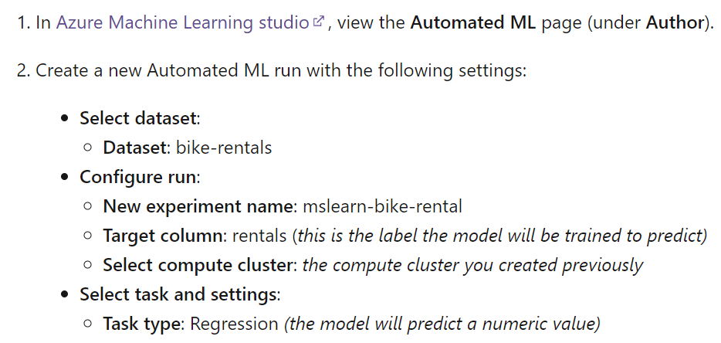

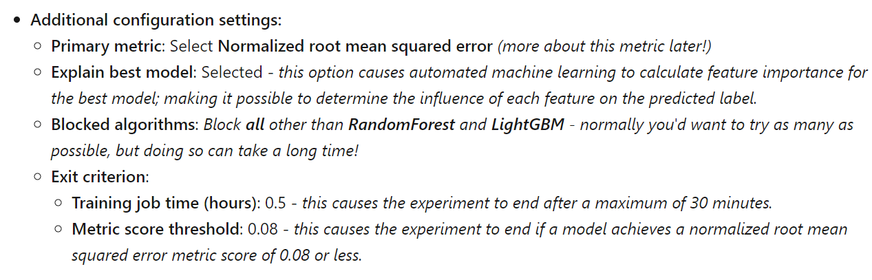

## [Create a Regression Model with Azure Machine Learning designer](https://docs.microsoft.com/en-us/learn/modules/create-regression-model-azure-machine-learning-designer/?ns-enrollment-type=LearningPath&ns-enrollment-id=learn.wwl.create-no-code-predictive-models-with-azure-machine-learning)

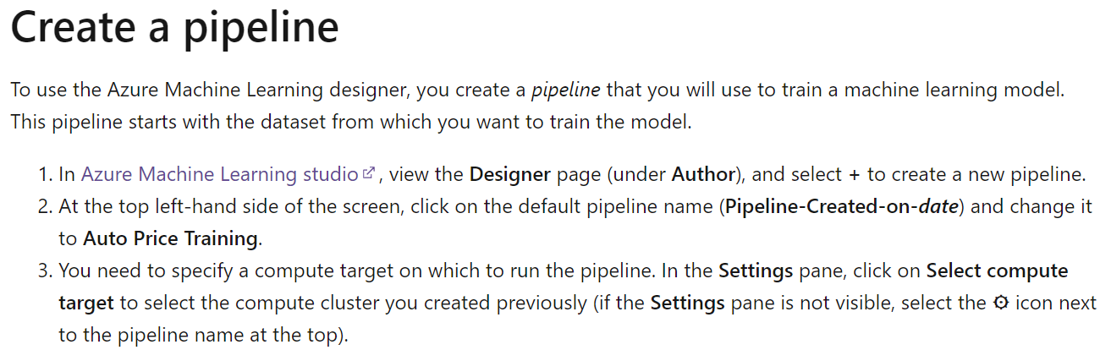

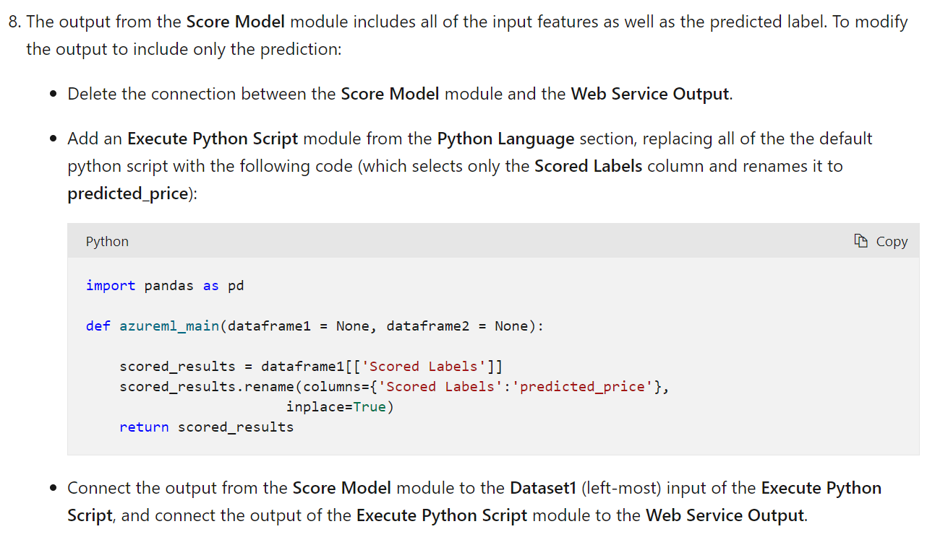

## [Create a classification model with Azure Machine Learning designer](https://docs.microsoft.com/en-us/learn/modules/create-classification-model-azure-machine-learning-designer/?ns-enrollment-type=LearningPath&ns-enrollment-id=learn.wwl.create-no-code-predictive-models-with-azure-machine-learning)

## [Create a Clustering Model with Azure Machine Learning designer](https://docs.microsoft.com/en-us/learn/modules/create-clustering-model-azure-machine-learning-designer/?ns-enrollment-type=LearningPath&ns-enrollment-id=learn.wwl.create-no-code-predictive-models-with-azure-machine-learning)

# Build and operate machine learning solutions with Azure Machine Learning

## [Introduction to the Azure Machine Learning SDK](https://docs.microsoft.com/en-us/learn/modules/intro-to-azure-machine-learning-service/?ns-enrollment-type=LearningPath&ns-enrollment-id=learn.data-ai.build-ai-solutions-with-azure-ml-service)

## [Train a machine learning model with Azure Machine Learning](https://docs.microsoft.com/en-us/learn/modules/train-local-model-with-azure-mls/?ns-enrollment-type=LearningPath&ns-enrollment-id=learn.data-ai.build-ai-solutions-with-azure-ml-service)

## [Work with Data in Azure Machine Learning](https://docs.microsoft.com/en-us/learn/modules/work-with-data-in-aml/?ns-enrollment-type=LearningPath&ns-enrollment-id=learn.data-ai.build-ai-solutions-with-azure-ml-service)

## [Work with Compute in Azure Machine Learning](https://docs.microsoft.com/en-us/learn/modules/use-compute-contexts-in-aml/?ns-enrollment-type=LearningPath&ns-enrollment-id=learn.data-ai.build-ai-solutions-with-azure-ml-service)

## [Orchestrate machine learning with pipelines](https://docs.microsoft.com/en-us/learn/modules/create-pipelines-in-aml/?ns-enrollment-type=LearningPath&ns-enrollment-id=learn.data-ai.build-ai-solutions-with-azure-ml-service)

## [Deploy real-time machine learning services with Azure Machine Learning](https://docs.microsoft.com/en-us/learn/modules/register-and-deploy-model-with-amls/?ns-enrollment-type=LearningPath&ns-enrollment-id=learn.data-ai.build-ai-solutions-with-azure-ml-service)

## [Deploy batch inference pipelines with Azure Machine Learning](https://docs.microsoft.com/en-us/learn/modules/deploy-batch-inference-pipelines-with-azure-machine-learning/?ns-enrollment-type=LearningPath&ns-enrollment-id=learn.data-ai.build-ai-solutions-with-azure-ml-service)

## [Tune hyperparameters with Azure Machine Learning](https://docs.microsoft.com/en-us/learn/modules/tune-hyperparameters-with-azure-machine-learning/?ns-enrollment-type=LearningPath&ns-enrollment-id=learn.data-ai.build-ai-solutions-with-azure-ml-service)

## [Automate machine learning model selection with Azure Machine Learning](https://docs.microsoft.com/en-us/learn/modules/automate-model-selection-with-azure-automl/?ns-enrollment-type=LearningPath&ns-enrollment-id=learn.data-ai.build-ai-solutions-with-azure-ml-service)

## [Explore differential privacy](https://docs.microsoft.com/en-us/learn/modules/explore-differential-privacy/?ns-enrollment-type=LearningPath&ns-enrollment-id=learn.data-ai.build-ai-solutions-with-azure-ml-service)

## [Explain machine learning models with Azure Machine Learning](https://docs.microsoft.com/en-us/learn/modules/explain-machine-learning-models-with-azure-machine-learning/?ns-enrollment-type=LearningPath&ns-enrollment-id=learn.data-ai.build-ai-solutions-with-azure-ml-service)

## [Detect and mitigate unfairness in models with Azure Machine Learning](https://docs.microsoft.com/en-us/learn/modules/detect-mitigate-unfairness-models-with-azure-machine-learning/?ns-enrollment-type=LearningPath&ns-enrollment-id=learn.data-ai.build-ai-solutions-with-azure-ml-service)

## [Monitor models with Azure Machine Learning](https://docs.microsoft.com/en-us/learn/modules/monitor-models-with-azure-machine-learning/?ns-enrollment-type=LearningPath&ns-enrollment-id=learn.data-ai.build-ai-solutions-with-azure-ml-service)

## [Monitor data drift with Azure Machine Learning](https://docs.microsoft.com/en-us/learn/modules/monitor-data-drift-with-azure-machine-learning/?ns-enrollment-type=LearningPath&ns-enrollment-id=learn.data-ai.build-ai-solutions-with-azure-ml-service)

## [Explore security concepts in Azure Machine Learning](https://docs.microsoft.com/en-us/learn/modules/azure-machine-learning-security/?ns-enrollment-type=LearningPath&ns-enrollment-id=learn.data-ai.build-ai-solutions-with-azure-ml-service)